Raspberry Pi Lab

Objectives:

1. Basic computer theory, Raspberry Pi components and how to utilize
2. OS Flashing
3. SSH and VNC
4. Input and Output

Basic computer theory

All general-purpose computers require the following hardware components:

* [**Memory**](https://www.webopedia.com/TERM/M/memory.html)**:** enables a computer to [store](https://www.webopedia.com/TERM/S/store.html), at least temporarily, data and programs.
* [**Mass storage**](https://www.webopedia.com/TERM/M/mass_storage.html) [**device**](https://www.webopedia.com/TERM/D/device.html)**:** allows a computer to permanently retain large amounts of data. Common mass storage devices include [solid state drives](https://www.webopedia.com/TERM/S/solid_state_disk.html) (SSDs) or [disk drives](https://www.webopedia.com/TERM/D/disk_drive.html) and [tape drives](https://www.webopedia.com/TERM/T/tape_drive.html).
* [**Input device**](https://www.webopedia.com/TERM/I/input_device.html)**:** usually a [keyboard](https://www.webopedia.com/TERM/K/keyboard.html) and [mouse](https://www.webopedia.com/TERM/M/mouse.html), the input device is the conduit through which data and instructions enter a computer.
* [**Output device**](https://www.webopedia.com/TERM/O/output_device.html)**:** a [display screen](https://www.webopedia.com/TERM/D/display_screen.html), [printer](https://www.webopedia.com/TERM/P/printer.html), or other device that lets you see what the computer has accomplished.
* [**Central processing unit**](https://www.webopedia.com/TERM/C/CPU.html) **(CPU):** the heart of the computer, this is the component that actually executes instructions.

In addition to these components, many others make it possible for the basic components to work together efficiently. For example, every computer requires a [bus](https://www.webopedia.com/TERM/B/bus.html) that transmits data from one part of the computer to another.

Raspberry Pi

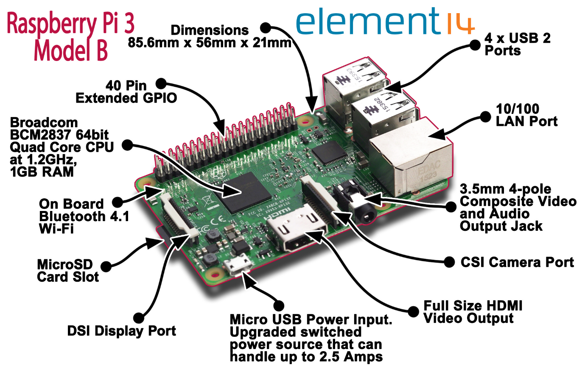

Raspberry Pi vs Arduino

An Arduino is a microcontroller motherboard. A microcontroller is a simple computer that can run one program at a time, over and over again. It is very easy to use.

A Raspberry Pi is a general-purpose computer, usually with a Linux operating system, and the ability to run multiple programs. It is more complicated to use than an Arduino.

Generally, think about what you want your project to do. If you can describe it with less than two ‘and’s, get an Arduino. If you need more than two ‘and’s, get a Raspberry Pi.

Examples:  
“I want to monitor my plants and have them Tweet me when they need water.” That can best be done by an Arduino.

“I want to monitor my plants and have them Tweet me when they need water and check the National Weather Service, and if the forecast is for fair weather, turn on the irrigation system and if the forecast is for rain, do nothing.” That would best be handled by a Raspberry Pi.

Pinout

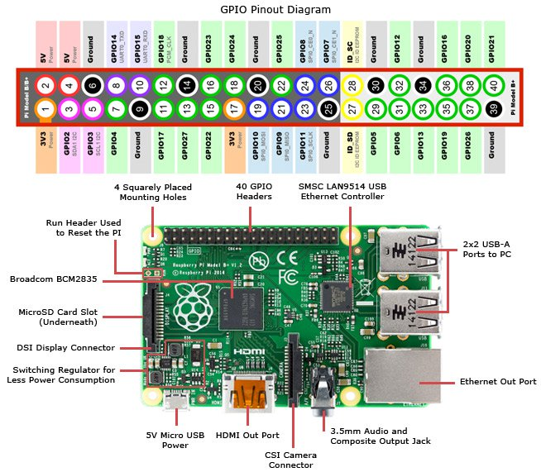

If you forget you can type pinout in the command line

.

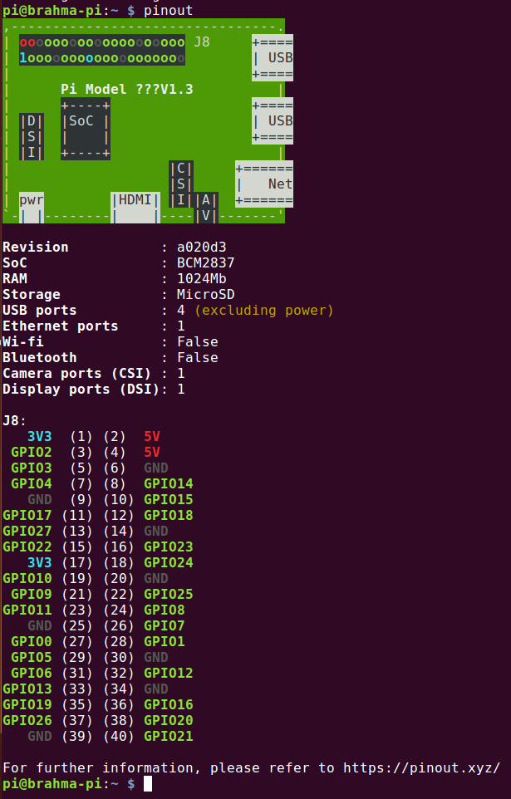

2. OS flashing

We will begin by flashing Raspbian into RPI.

Step 1. Go to <https://www.raspberrypi.org/downloads/noobs/> Click on NOOBS zip file offline

Save into any drive you want. Remember the path you installed it into.

Step 2. Open Balena Etcher. When file has finished downloading click on select image, your inserted empty and formatted SD card(More than 8GB) and click flash and wait for it to flash. This will take about 5 mins.

Congrats you have installed an OS.

Step 3 Go to (My G drive sharing link)

Step 4 Copy file WPA supplicant.conf and copy it into boot folder(ignore format prompts and just click on red cross button)

Step 5 Create file in boot of SD card, ssh without any file extensions

Step 6 Insert Card into RPI and wait for Yellow light to flash

Step 7 Use Advanced IP Scanner to figure out IP of RPI. Do this by obtaining your Own Ipv4 by running cmd command ipconfig on Windows. Mac Users go to terminal and type  ipconfig getifaddr en0 . On advanced IP scanner replace last 2 digits by 1-254 and click scan.

Step 8 Open Putty. Paste IP into it. Make sure it is connected to port 22.

Congrats you have SSH into RPI

Step 9 Default Username is pi

Password is raspberry

Type into terminal sudo raspi-config

Step 10. Navigate to Option 5 Interfacing objects and enable SSH and VNC server

Step 11. Open VNC viewer and Paste IP into bar ontop

You will be prompted to enter password and username these are raspberry and pi respectively.

Congrats you now in a remote setup for RPI

Output

We will now begin with writing a simple python script to cause led connected to GPIO to blink

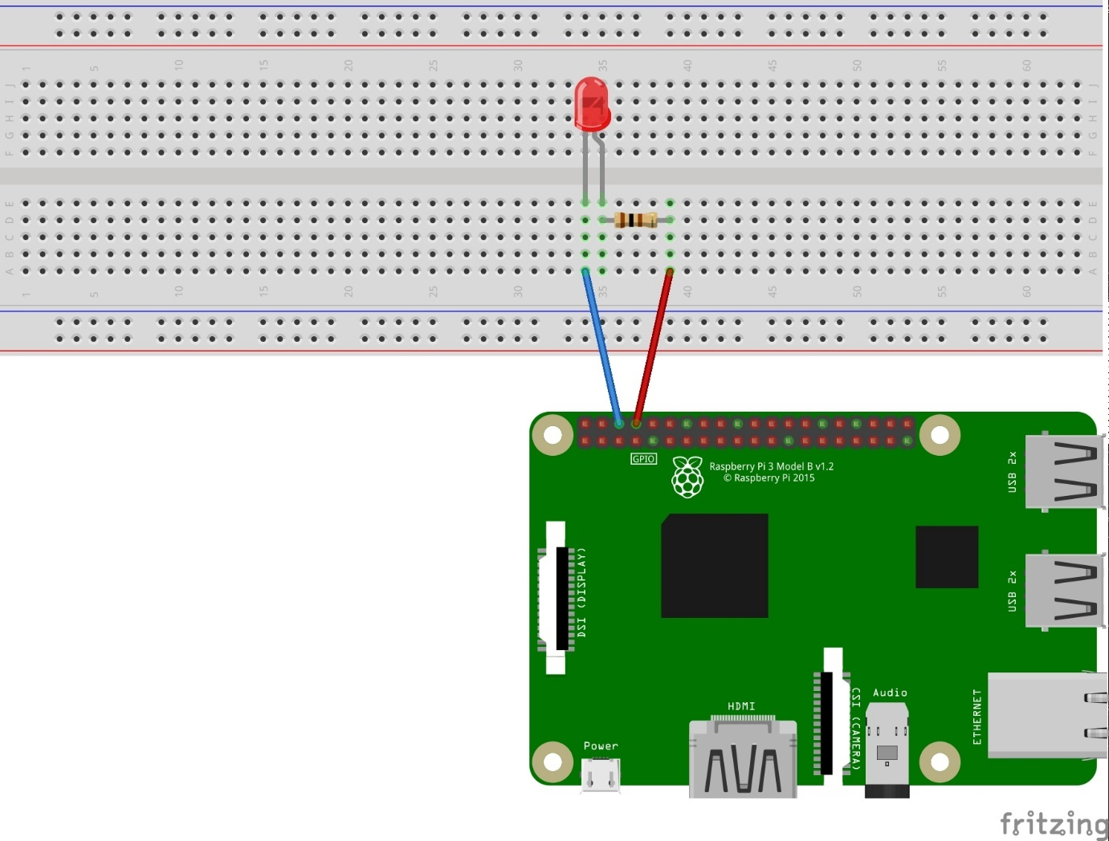

Enter Python 3 IDE and click file>New python file

Copy this code

Click run and LED should be blinking.

Stop Blink by pressing ctrl c

Shutdown by pressing raspberry logo then clicking shutdown